1. Create a program with Top Include.

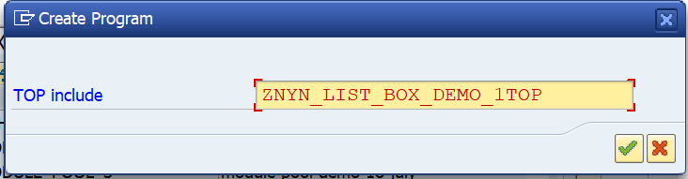

TYPE – MODULE POOL

1. Create a screen

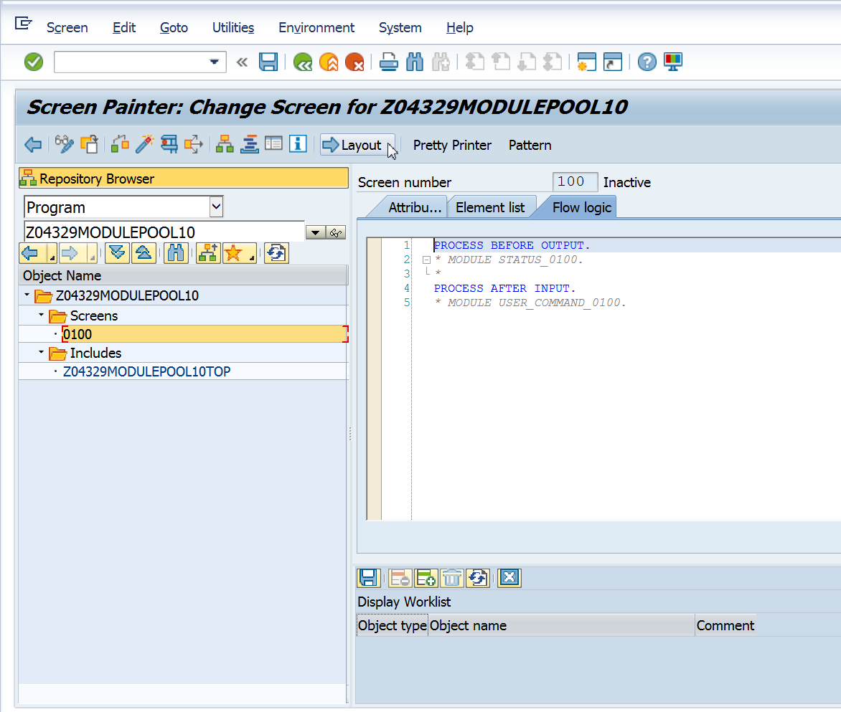

1. CLICK ON LAYOUT BUTTON
2. Click on Get from dictionary icon.  
    Give table name SCARR. Click on Get from dictionary. Select anyone field. I have selected field CARRID

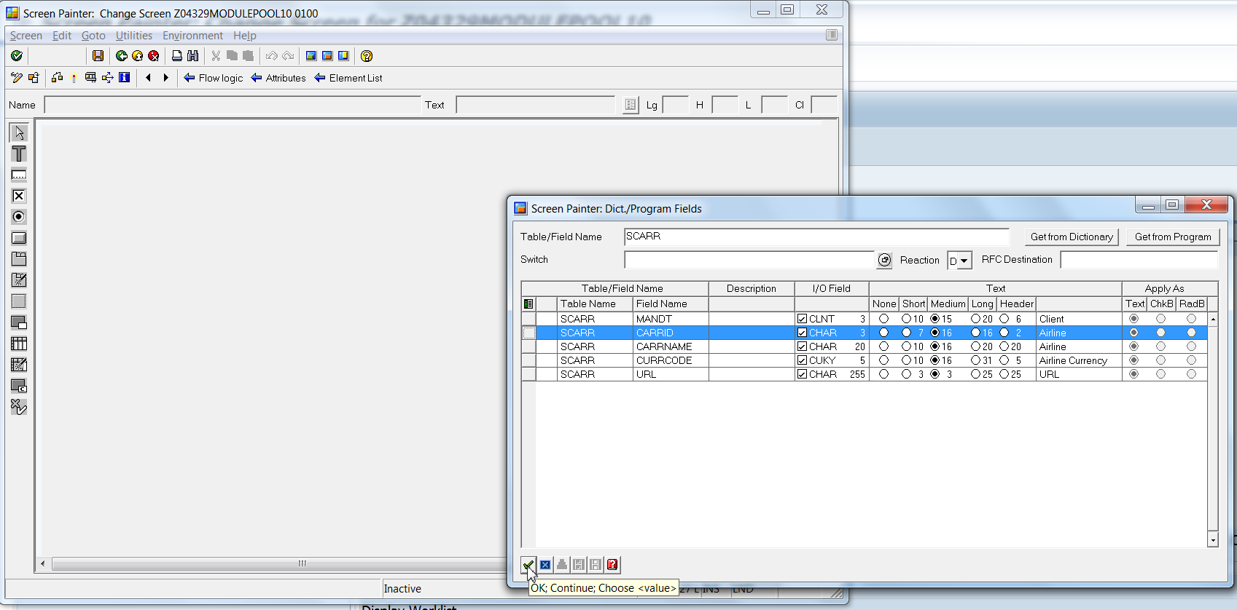

1. In the property window, Dropdown field is set to ListBox.   
   The drop down arrow appears that means it is a list box.

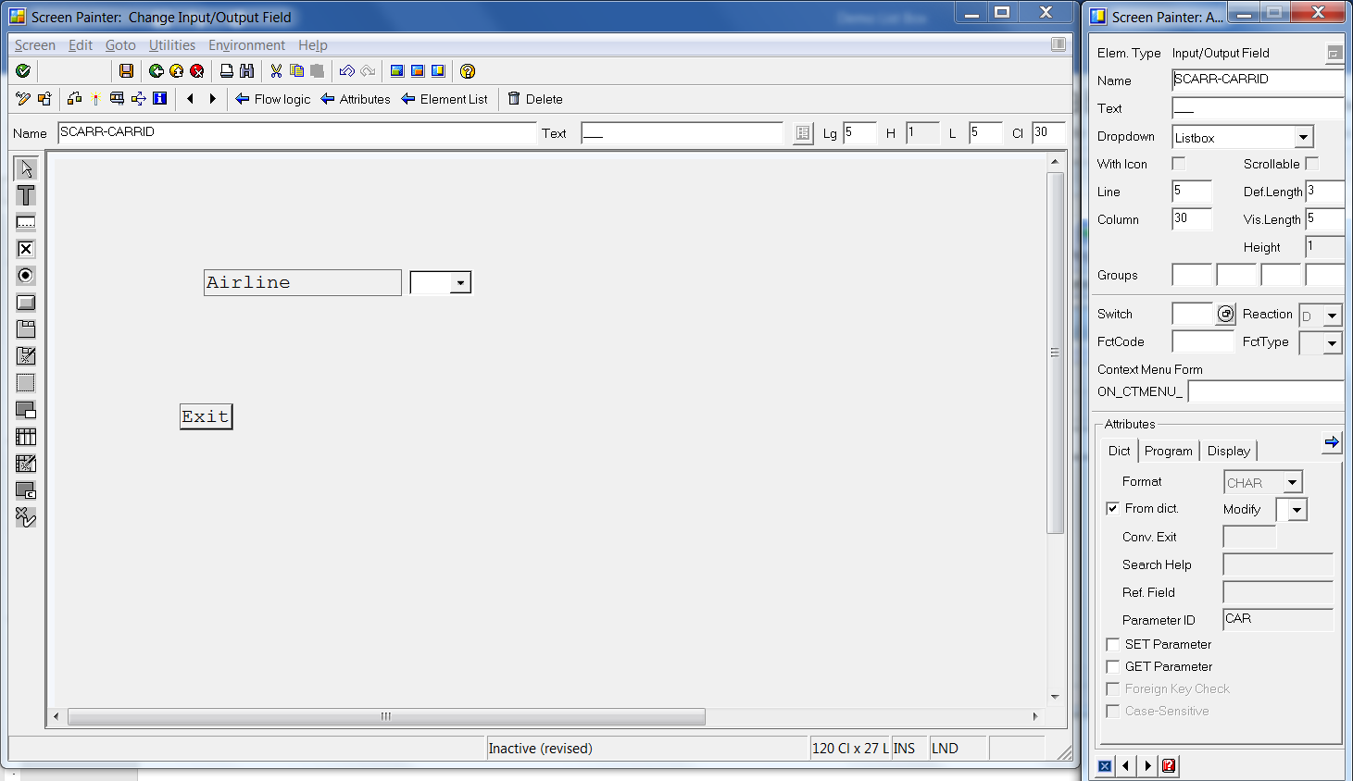

1. Code the following in PBO.

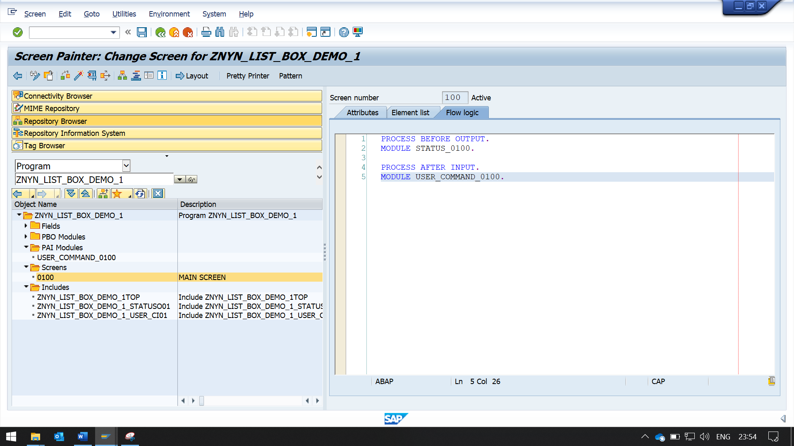

UNCOMMENT STATUS_0100 MODULE AND USER_COMMAND_0100 MODULE

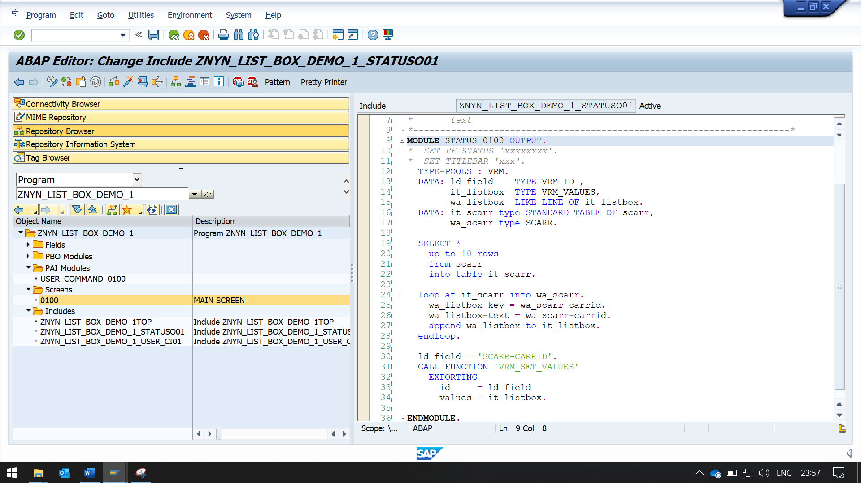

WRITE THIS CODE IN STATUS_0100 MODULE

TYPE-POOLS : VRM.  
  DATA: ld_field    TYPE VRM_ID ,  
        it_listbox  TYPE VRM_VALUES,  
        wa_listbox  LIKE LINE OF it_listbox.  
  DATA: it_scarr type STANDARD TABLE OF scarr,  
        wa_scarr type SCARR.  
  
  SELECT *  
    up to 10 rows  
    from scarr  
    into table it_scarr.  
  
  loop at it_scarr into wa_scarr.  
    wa_listbox-key = wa_scarr-carrid.  
    wa_listbox-text = wa_scarr-carrid.  
    append wa_listbox to it_listbox.  
  endloop.  
  
  ld_field = 'SCARR-CARRID'.  
  CALL FUNCTION 'VRM_SET_VALUES'  
    EXPORTING  
      id     = ld_field  
      values = it_listbox.

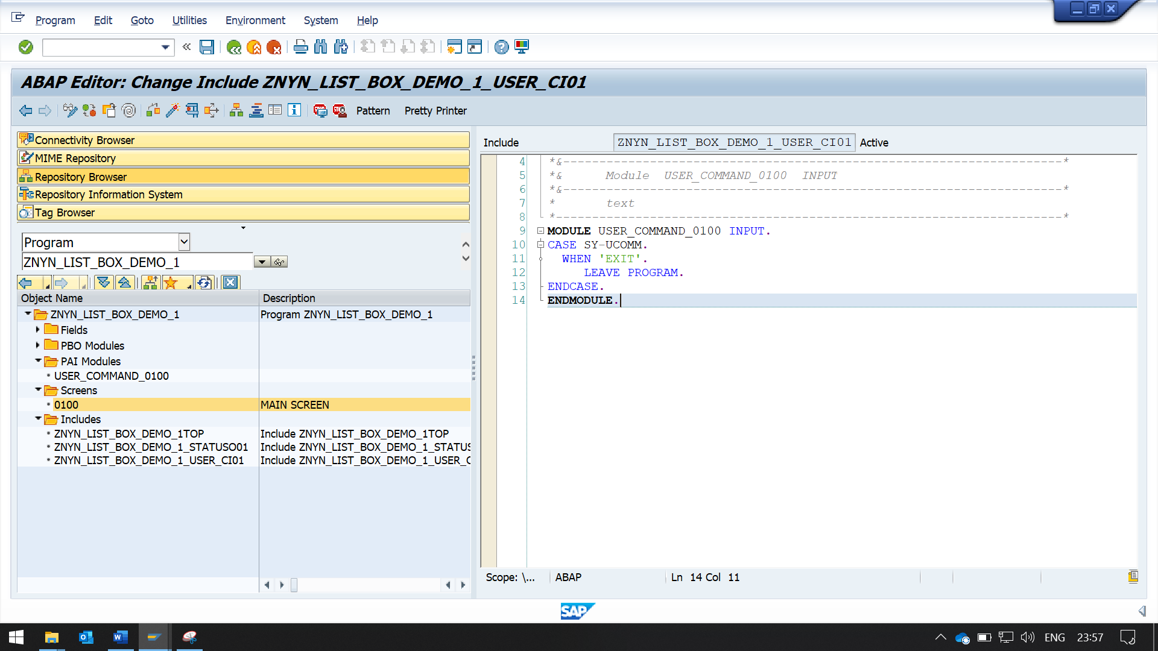

Code the following in PAI I in module user_command_0100.

MODULE user_command_0100 INPUT.  
CASE SY-UCOMM.  
  WHEN 'EXIT'.  
     LEAVE PROGRAM.  
ENDCASE.   
ENDMODULE.